Alex Messina

**“Terrigenous sediment dynamics in a small, tropical fringing-reef embayment”**

*Prepared for Oral Exam and Proposal Defense*

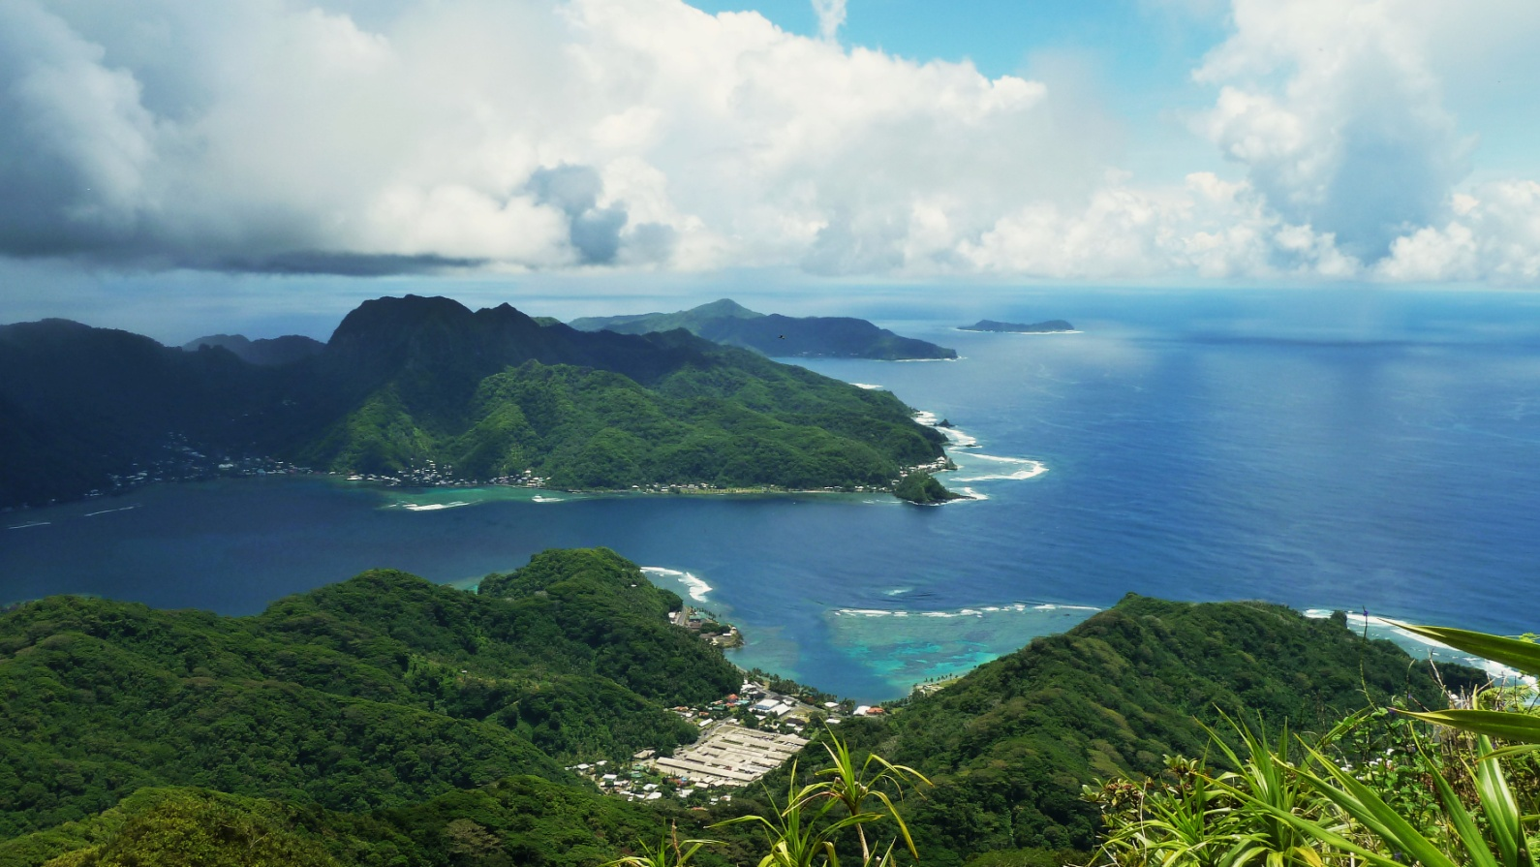

**Doctoral Committee:**

Trent Biggs (Chair)

Bodo Bookhagen

Alan Hope

Curt Storlazzi

Libe Washburn

# Proposal Introduction

## Motivation

Anthropogenic watershed disturbance by industry, agriculture, deforestation, roads, and urbanization alters the timing, composition, and mass of sediment loads to coral reefs, causing enhanced sediment stress on corals near the outlets of impacted watersheds (Syvitski et al., 2005; West and van Woesik, 2001). Anthropogenic sediment disturbance may be exacerbated on tropical islands characterized by high rainfall, extreme weather events, steep slopes, erodible soils, and naturally dense vegetation, where land clearing alters the fraction of exposed soil much more than in regions with sparse vegetation. Sediment can bond with and transport other pollutants, attenuate light for photosynthesis, prevent larval recruitment, and stress or smother coral organisms (Fabricius, 2005). Deposited sediment can be resuspended due to wave action and reworked over the reef, causing persistent negative effects to ecosystem health (Wolanski et al., 2003) or distributing impacts to larger areas (Presto et al., 2006). Damage to coral organisms and ecosystems is determined by the magnitude and duration of exposure, which are controlled by the interaction of sediment loading from the watershed, sediment availability on the reef, and hydrodynamic processes (Storlazzi et al., 2009). An integrated understanding of how flood-supplied terrigenous sediment and water circulation control sediment deposition and residence time on reefs is essential for identifying and mitigating impacts on coral health (Brodie et al., 2012; Draut et al., 2009).

## Previous Research and Scientific Motivation

The USGS Ridge-to-Reef Program (see Field et al. (2008), and references therein) has pursued integrated, process-oriented research in tropical, fringing reefs to provide scientific information on sediment sources and dynamics to resource managers (Atkinson and Medeiros, 2006). Coral sediment dynamics studies like Ridge-to-Reef have three general components, which are reflected in the three chapter structure of this dissertation: watershed inputs, hydrodynamic circulation over the reef, and how they interact to govern spatiotemporal distribution of sediment accumulation on the reef. Each of the three components requires significant expertise and specialized equipment, so most studies have either focused on only one component, or integrated large-scale collaborative efforts among watershed scientists, oceanographers, and coral ecologists. These large-scale collaborative efforts are important for integrating state-of-the-art knowledge in each field, but are generally beyond the capabilities of management-oriented investigations, or focus on large, complex study sites (Fabricius et al., 2012; Storlazzi et al., 2009).

Few studies have developed an integrated understanding of sediment sources, transport processes, and deposition in small, reef-fringed embayments (Bartley et al., 2014; Draut et al., 2009; Wolanski et al., 2003). Two integrated studies of Hanalei Bay in Kauai, HI, (Draut et al., 2009; Storlazzi et al., 2009) demonstrated that in addition to total sediment loading and water circulation, the temporal phasing of flood events and seasonal wave conditions is a key control on sediment deposition and residence time. As opposed to temperate regions where sediment deposition is limited because river floods and high wave energy are caused by the same frontal system, sediment discharge and wave events can be decoupled in many tropical regions.

# Research Design

The objective of this dissertation is to document relationships and interactions between terrigenous sediment, water circulation over the reef, and the spatial distribution of sediment accumulation under various conditions in a linked watershed and fringing-reef embayment. This research is structured around three separate papers that develop an empirical model of sediment dynamics in Faga’alu, American Samoa, which has been identified as a priority reef for mitigation of sediment-related impacts on coral reefs (Burke et al., 2011).

***Paper One,*** “*Contributions of human activities to suspended sediment yield during storm events from a steep, small, tropical watershed”,* will quantify background sediment loading from undisturbed forest and from human disturbed parts of two watersheds during both baseflow and storm events. A combination of paired- and nested-watershed study designs using sediment budget, disturbance ratio, and sediment rating curve methodologies will quantify the contribution of human-disturbed areas to total suspended sediment yield (SSY). In situ measurements of precipitation, stream discharge and suspended sediment concentration, collected over three field campaigns (2012-2014), are used to estimate per-storm-event suspended sediment yield (SSYEV) from the natural and human-impacted subwatersheds. An empirical model of SSYEV will 1) determine which characteristics of precipitation and discharge control SSYEV (Duvert et al., 2012), 2) provide a baseline to assess the effectiveness of future sediment mitigation at the quarry, and 3) will provide input to a model of sediment accumulation on the reef, developed in Paper Three.

***Paper Two,*** “*Eulerian and Lagrangian measurements of water flow and residence time on a fringing reef embayment”*, will use a combination of Lagrangian (GPS-logging drifters) and Eulerian methods (Acoustic Doppler Current Profilers) deployed over an intensive two-week field campaign to characterize flow velocities over the reef, and their relationship to wave, wind, and tidal forcing. Flow velocities are used to develop a model of spatially distributed residence time of water over the reef, based on model output of wave height (NOAA WaveWatchIII III), and routinely collected wind velocity and tidal stage. The developed model of water residence time will be incorporated as a component of a model of sediment accumulation on the reef developed in Paper Three.

***Paper Three, “****Watershed and oceanic controls on spatial and temporal patterns of sediment accumulation in a fringing reef flat embayment”,* will use measurements of monthly terrigenous sediment accumulation on the reef to develop a spatially distributed model of net sediment accumulation based on sediment input and water residence time in the Bay. Sediment input from the watershed will be estimated from the model of sediment loading developed in Paper One, and water residence time will be estimated from the model developed in Paper Two.

## Funding sources for fieldwork

Stream monitoring in Faga’alu and Nu’uuli was funded by two National Oceanic and Atmospheric Agency (NOAA) Territorial Management grants (Award #CRI-AS-12 and CRI-AS-14, $45,000 and $63,000) administered by the Coral Reef Advisory Group in American Samoa (CRAG). Sediment accumulation monitoring in Faga’alu Bay was funded by the NOAA Coral Reef Conservation Program (CRCP)(Award #NA13NOS4820025, $55,000). The US Geological Survey’s (USGS) Coastal and Marine Geology Program Pacific Coral Reef Project supplied $64,000 in oceanographic equipment for the hydrodynamic studies in the bay.

The following section of the dissertation proposal is organized around each of the three papers outlined above:

# Paper One: “Contributions of human activities to suspended sediment yield during storm events from a steep, small, tropical watershed”

**Intended Journal:** [**Journal of Hydrology**](http://www.journals.elsevier.com/journal-of-hydrology/)**, Impact Factor: 3.65**

## Introduction

Successful reduction of sediment impacts to coral reefs requires identifying and quantifying key sources of terrigenous sediment to focus management efforts in the watershed and design mitigation measures. On Molokai, Stock et al. (2010) found that less than 5% of the land produces most of the sediment, and of that 5%, only 1% produces ~50% of the sediment, concluding that management should focus on mediating erosion hotspots (Risk, 2014). Knowledge of fluvial SSY on most Pacific volcanic islands remains limited due to difficulties associated with in situ monitoring, however existing sediment yield models are not well-calibrated to the climatic, topographic, and geologic conditions found on steep, tropical islands (Calhoun and Fletcher, 1999). Developing reliable models that predict SSY from small, mountainous catchments is a significant contribution for local coral conservation, and can also further improve models applied at the regional scale (Duvert et al., 2012).

SSY generated by individual storm events (SSYEV) may correlate with various precipitation and discharge variables (“storm metrics”), including total precipitation, the Erosivity Index, total discharge, or maximum event discharge (Qmax), but the best correlation has consistently been found with Qmax. Qmax integrates the whole hydrological response of a watershed, making it a good predictor variable of SSYEV in diverse environments (Duvert et al., 2012; Rankl, 2004). High correlation between SSYEV and Qmax has been found in semi-arid, temperate, and sub-humid watersheds in Wyoming (Rankl, 2004), Mexico, Italy, France (Duvert et al., 2012), and New Zealand (Basher et al., 2011; Hicks, 1990), but this approach has not been attempted for steep, tropical watersheds on volcanic islands.

The anthropogenic impact on SSY may vary by storm magnitude, as documented in Mediterranean climates (White and Greer, 2006) and in Pacific Northwest forests (Lewis et al., 2001). As storm magnitude increases, water and/or SSY from natural areas may increase relative to human-disturbed areas, diminishing anthropogenic impact. While large storms account for most SSY in natural conditions, human-disturbed areas may show the most significant disturbance for smaller storms (Lewis et al., 2001). It is hypothesized that the disturbance ratio (DR) is highest for small storms, when background SSY from the undisturbed forest is low and erodible sediment from disturbed surfaces in the lower watershed is the dominant source. For large storms, it is hypothesized mass movements and bank erosion contribute to naturally high SSY from the undisturbed upper watershed, reducing the DR for large events.

The research questions for this paper are:

1. How has human disturbance increased sediment loading to Faga’alu Bay?
2. How do sediment contributions from human-disturbed areas and undisturbed areas vary with storm size?
3. Which is the best predictor of storm event suspended sediment yield (SSYEV): total precipitation, Erosivity Index, total discharge, or maximum event discharge?

## Study Sites

The two study watersheds, Faga’alu and Nu’uuli, are characterized by large areas of undisturbed, steeply sloping, heavily forested hillsides in the upper watershed, and similarly steep topography with relatively small flat areas that are urbanized or densely settled in the lower watershed (Figure 1). This settlement pattern is typical for volcanic islands with steep topography in the south Pacific. Initial monitoring efforts focused on Faga’alu, which discharges to a sediment-impacted reef (Aeby et al., 2006). Faga’alu includes two unique features not found in “typical” watersheds in American Samoa: 1) an open aggregate quarry, and 2) a large impervious area associated with a hospital. Nu’uuli watershed is adjacent Faga’alu and is similar in precipitation, size, relief, and landcover, providing an opportunity to compare sediment loading from a more “typical” watershed and estimate the influence of the quarry and impervious area in Faga’alu.

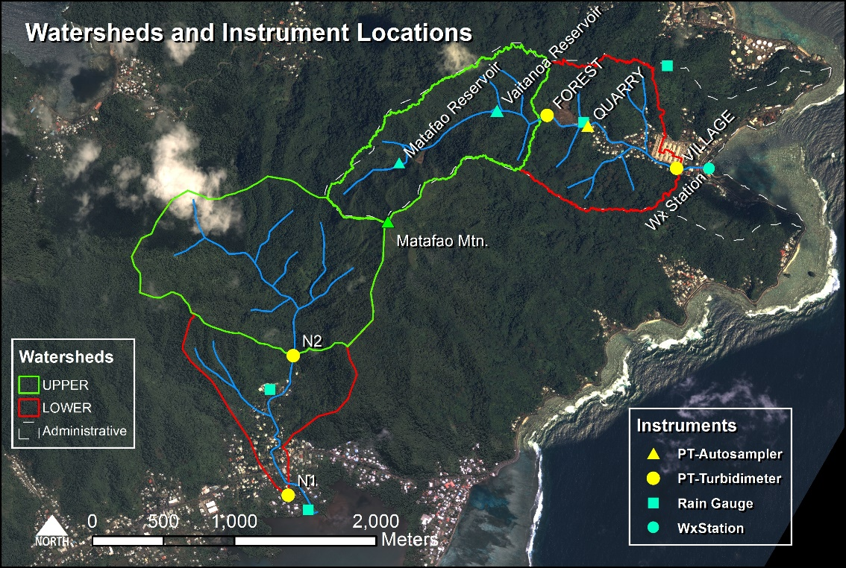

Figure Faga'alu and Nu'uuli watersheds showing upper (undisturbed) and lower (human-disturbed) subwatersheds.

## Methods

A combination of paired- and nested-watershed study designs will be used to assess SSY in the study watersheds during baseflow, and during storm events of varying magnitude. The paired watershed approach will be used to compare SSY from undisturbed and human-disturbed areas in Faga’alu with similar areas in Nu’uuli. The nested watershed approach will be used to quantify the contribution from undisturbed and human-disturbed areas to total sediment loading to Faga’alu Bay. While steep, mountainous streams can discharge large amounts of bedload (Milliman and Syvitski, 1992), this research is focused on sediment size fractions that can be transported in suspension in the marine environment to settle on corals, and this is generally restricted to silt and clay fractions (<16um) (Asselman, 2000).

### Predicting event suspended sediment yield (SSYEV)

SSY generated by individual storm events (SSYEV) can be used to compare the responses of different watersheds (Basher et al., 2011; Duvert et al., 2012; Fahey et al., 2003; Hicks, 1990), assess the contribution of individual subwatersheds to total SSY (Zimmermann et al., 2012), and determine changes in SSY from the same watershed over time (Bonta, 2000). SSYEV is calculated by integrating continuous suspended sediment load from measured or modeled discharge (Q) and suspended sediment concentration (SSC) (Duvert et al., 2012):

|  |  |  |
| --- | --- | --- |
|  |  | Equation 1 |
| where *SSYEV* is suspended sediment yield (tons) from t=0=storm start to T=storm end, *SSC* is suspended sediment concentration (mg/L), and *Q* is discharge (L/sec). | | |

SSYEV may be correlated with precipitation or discharge variables (“storm metrics”). Four storm metrics tested in this research will be total event precipitation (Psum), EI30 rainfall erosivity (EI30) (Hicks, 1990), total event discharge (Qsum), and peak event discharge (Qmax) (Duvert et al., 2012). Storm metrics may be linearly or nonlinearly correlated with SSYEV, so both Pearson’s and Spearman’s correlation coefficients will be calculated to select the best predictor of SSYEV from the total watershed, and from each subwatershed.

The relationship between SSYEV and storm metrics may be a linear function, but is often best fit by a watershed-specific power law function of the form:

|  |  |  |
| --- | --- | --- |
|  |  | Equation 2 |
| where X is a storm metric, and the regression coefficients α and β are obtained by ordinary least squares regression on the logarithms of *SSYEV* and *X* (Basher et al., 2011; Duvert et al., 2012; Hicks, 1990), normalized for watershed area. Linear functions will be fit to untransformed (Linear) and log-transformed dependent and independent variables (Power Law), and best fit will be determined by coefficients of determination (r2). | | |

### Sediment budget and Disturbance Ratio

A sediment budget quantifies the contribution of key sediment sources to the overall sediment yield (Bartley et al., 2012; Reid and Dunne, 1996; Slaymaker, 2003; Warrick and Mertes, 2009). The percent contribution of each subwatershed to SSY from the total watershed will be calculated as the difference between SSYEV observed at the upstream and downstream monitoring stations.

The disturbance ratio (DR) is the ratio of SSYEV from the total human-disturbed watershed under current conditions (measured at the watershed outlet: VILLAGE and N1) to SSY under pre-disturbance conditions (SSYpre):

|  |  |  |
| --- | --- | --- |
|  |  | Equation 3 |

SSYpre is calculated assuming that the specific SSY from forested parts of the lower watershed is similar to the specific SSY from the upper watershed:

|  |  |  |
| --- | --- | --- |
|  |  | Equation 4 |

The percent contribution and DR will be calculated for each storm and averaged to determine the contribution of each subwatershed to total SSY.

### Field Data Collection

Field data were collected over three main field campaigns, coinciding with the wet season and high storm probability, and several periods of unattended monitoring from January, 2012, to March, 2014. A combination of continuously measured precipitation, turbidity and water stage, and discrete grab samples collected during baseflow and storm events at five sampling locations (FOREST, QUARRY, VILLAGE, N1, and N2; Figure 1) will be used to calculate SSYEV and storm metrics. Turbidimeters installed at four locations (FOREST, VILLAGE, N2 and N1) monitored turbidity (T) at 15 min intervals. Continuous SSC will be calculated from T data and a T-SSC relationship calibrated with SSC grab samples over a range of T values (Gippel, 1995; Lewis, 1996). If T data are unavailable due to instrument error, but sufficient stream water grab samples are collected during a given storm (n>3), SSYEV will be calculated using event mean concentration (EMC) and measured Q (Bartley et al., 2012; Harmel et al., 2006b; Lewis et al., 2001). SSY from the quarry, a key sediment source in Faga’alu, will be calculated using the specific water discharge (q) from forested areas for undisturbed areas (measured at FOREST) and using the SCS Curve Number approach for disturbed areas (Garen and Moore, 2005), and EMC of samples collected by an ISCO 3700 Autosampler at 30 min intervals installed at QUARRY (Figure 1). More detailed description of data collection and methods can be found in the companion document “Quality Assurance Project Plan: Physical Monitoring of Surface Waters in American Samoa.”

### Uncertainty

Uncertainty in SSYEV (Equation 1) estimates arises from both measurement and model errors, including models of stage-discharge (Stage-Q) and T-SSC (Harmel et al., 2006a). The Root Mean Square Error (RMSE) method estimates the ‘‘most probable value’’ of the cumulative or combined error by propagating the error from each measurement and modeling procedure to the final SSYEV estimate (Topping, 1972). The resulting cumulative probable error (uncertainty) is the square root of the sum of the squares of the maximum values of the separate errors:

|  |  |  |
| --- | --- | --- |
|  |  | Equation 5 |
| where PE is the cumulative probable error for individual measured values (±%), EQmeas = uncertainty in Q measurements (±%), ESSCmeas = uncertainty in SSC measurements (± %), EQmod = uncertainty in Q modeled by the Stage-Q relationship (RMSE, as ±% of the mean observed Q), ESSCmod = uncertainty in SSC modeled by the T-SSC relationship (RMSE, as ± % of the mean observed SSC)(Harmel et al., 2009). | | |

PE will be calculated for each storm event to add statistical measures of uncertainty to estimates of SSYEV (±tons). The effect of uncertain SSYEV estimates may complicate conclusions about SSYEV-Qmax relationships, contributions from subwatersheds, and anthropogenic impacts. This is common in sediment yield studies where successful models estimate SSY with ±50-100% accuracy (Duvert et al., 2012), but it is believed that the difference in SSYEV from the upper and lower subwatersheds will be significantly larger than the uncertainty in the SSY estimates.

## Expected Results/Outcomes

The resulting empirical model of SSYEV to Faga’alu Bay will be used by NOAA’s CRCP to assess the effectiveness of future sediment mitigation at the quarry by a third party, scheduled for Summer 2014, and as a component of an empirical model of sediment accumulation on the reef developed in Paper Three. The developed models of SSYEV will also be useful for advancing research efforts towards regional and global prediction of SSYEV from peak discharge in small, mountainous watersheds (Duvert et al., 2012).

# Paper Two: “Eulerian and Lagrangian measurements of water flow and residence time in a fringing reef embayment”

**Intended journal:** [**Coral Reefs**](http://www.springer.com/life+sciences/ecology/journal/338)**, Impact Factor: 3.66**

## Introduction

Hydrodynamic conditions on coral reefs influence biologically important processes like nutrient cycling, larval dispersal, and temperature regimes (Falter et al., 2004; Wyatt et al., 2012). By controlling orbital velocities, bed shear stresses, and water residence time, hydrodynamic conditions are also a primary control on the spatiotemporal distribution of deposition, resuspension, and dispersal of terrigenous sediment (Draut et al., 2009; Hoitink and Hoekstra, 2003; Presto et al., 2006; Storlazzi et al., 2009, 2004). Currently, coral conservation planning is done with estimations of pollutant discharge and distance-based plume models (Doheny et al., 2013; Klein et al., 2012), but studies in Hanalei Bay showed that fringing-reef environments are characterized by heterogeneous waves and currents over relatively small (hundreds of meters) spatial scales, unlike linear sandy shorelines (Hoeke et al., 2011; Storlazzi et al., 2009). Understanding the velocities and residence time of water over the reef flat is critical for understanding spatial and temporal patterns of sediment accumulation that influence reef health.

Studies in various coral reef environments adjacent steep, volcanic islands have shown current velocities and water residence times over reef flats are controlled by wave, wind, and tidal forcing, depending on the orientation and morphology of the reef, relative to the prevailing wave, wind, and tidal climates (Hench et al., 2008; Hoeke et al., 2011; Presto et al., 2006; Storlazzi and Jaffe, 2008; Storlazzi et al., 2004). Buoyancy forcing from hypopycnal river floods is generally ignored or considered inconsequential due to their rarity and short duration relative to other forcings (Hench et al., 2008; Hoeke et al., 2011). Current velocities over reefs exposed to remotely-generated groundswells are generally dominated by wave forcing (Hench et al., 2008; Hoeke et al., 2011; Vetter et al., 2010), whereas wind forcing is dominant over reefs protected from groundswells (Presto et al., 2006; Storlazzi et al., 2004). Tidal forcing is considered minor in microtidal environments, however, tidal elevation modulates both wave- and wind-driven currents by controlling the propagation of wave energy over the reef crest, and by regulating water depth for wind-driven surface wave development (Presto et al., 2006).

Fringing-reef embayments in small, tropical volcanic islands have several common features that influence circulation and residence time. Most have a deep central channel (‘ava in Samoan language) flanked by shallow reef flats on either side. Flow velocities in wave-driven environments typically exhibit a pattern of rapid, cross-shore flow near the reef crest that slows and turns along-shore towards a deep channel where water returns seaward, limiting cross-shore exchange of sediment from the reef flat to the forereef (Hench et al., 2008; Lowe et al., 2009; Wyatt et al., 2010). In wind-driven systems, flows are more predominantly in the direction of the wind with possible cross-shore water and sediment exchange from the reef flat to the forereef (Storlazzi et al., 2004), distributing sediment impacts from the muddy reef flat to the forereef (Presto et al., 2006). Observations on the wind-dominated reef flat in Molokai, Hawaii, showed current speeds were faster where the reef is deeper and narrower (Storlazzi et al., 2006c) but field observations at the wave-dominated proposed study site suggest the opposite; current speeds are rapid over the shallow reef crest, slowing significantly when reaching deeper pools in the reef and the main channel that bisects the reef. I anticipate that the spatial configuration of the reef flats and channel and their orientation vis-à-vis the dominant wave direction serve as primary controls on the spatial distribution of circulation and residence time.

Little data on current circulation is available for American Samoa, and almost no data on circulation over the reef flat has been collected (CH2M HILL, 1984; Jacob et al., 2012; Wiles et al., 2012). Vetter (2013) concluded flow dynamics in the bay were predominantly forced by waves breaking over the southern reef crest, and the wave influence increased linearly with tide height. While Vetter (2013) used wave/tide data and current speed in the main channel to calculate flushing time, those calculations are highly dependent on bathymetric data which are not well verified, and do not provide information on the spatial variation of flow velocities. Since it is known that water residence time, in addition to water quality, is a strong control on sediment impacts to coral health, it is desirable to characterize spatially distributed residence times in relation to wave, wind, and tide forcing.

The research questions for this paper are:

1. How do flow velocities and residence time of ocean water over the reef vary spatially?
2. How are flow velocities and residence time of ocean water over the reef controlled by wave-, wind-, and tidal-forcing?

## Study Site

Faga’alu Bay is a V-shaped, reef-fringed embayment at the mouth of a small, steep-sided watershed (2.48 km2). An anthropogenically altered, vertical-walled, 10-20m deep paleo-stream channel extends from the mouth of Faga’alu Stream eastward to Pago Pago Bay, dividing the reef into a larger southern and a smaller northern section. A microtidal regime (0-1m) varies semi-diurnally, exposing parts of the shallow reef. Cross-reef transfer of water and wave energy is strongly dependent on the tidal stage and wave setup. Surrounding high topography blocks wet-season northerly winds (October-April) but the bay is exposed to dry-season southeasterly trade winds and accompanying short-period wind waves (May-September). Faga’alu Bay is exposed to a narrow window of swell directions (S-SE), and swells approaching from a southerly angle refract to the west to break directly on the reef, reducing the energy of breaking waves. Significant wave height (Hs) from southerly and southeasterly directions are generally less than 2.5m and rarely exceed 3m. Wave periods (Tp) are generally about 9 s or less, rarely exceed 13 s, but occasionally reach 25 s (Thompson and Demirbilek, 2002).

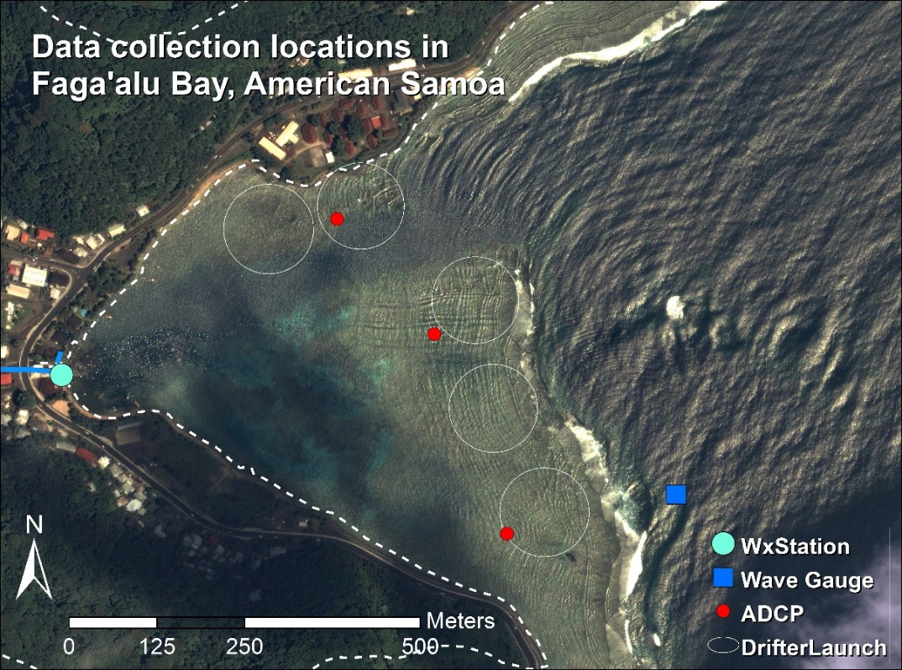

Figure . Data collection locations in Faga'alu Bay.

## Methods

### Combining Eulerian and Lagrangian measurements

A combination of Eulerian and Lagrangian measurements will be used to characterize spatially distributed flow velocities and residence time of water over the reef flat in Faga’alu Bay, and to determine their relationship with wave-, wind-, and tidal-forcing. Collecting high spatial resolution data of hydrodynamic processes using strictly Eulerian methods is expensive and logistically difficult (Storlazzi et al., 2006b, 2004), so Lagrangian methods, including GPS-logging drifters, will be used to map flow velocities, and compare with Eulerian measurements (Storlazzi et al., 2006a, 2004; Wyatt et al., 2012). Studies of rip currents in linear, sandy surf zones have used large numbers of GPS-logging drifters to capture synoptic measurements of small-scale flow structures and patterns (Johnson et al., 2003; MacMahan et al., 2010), but this approach has not been attempted in a shallow reef environment.

Compared to Eulerian methods, drifter studies in nearshore environments are typically limited in the number of observations and/or in the range of oceanic and meteorological forcing conditions experienced during deployments, making it uncertain whether they describe the dominant patterns, or short-lived anomalies (Storlazzi et al., 2006a; Wyatt et al., 2010). To determine if the short-term drifter deployments adequately describe long-term forcing conditions observed by the ADCP, two techniques will be used to compare the drifter results with ADCP results: Empirical orthogonal functions (EOF) and progressive vectors of cumulative flow (Storlazzi et al., 2006a). EOFs determine the dominant modes of flow in the spatial domain, and the observed patterns at any given time period are described as a linear combination of the different modes (Emery and Thomson, 2004). Variance ellipses are commonly calculated from ADCP data to describe the relative magnitude of flow direction in the cross- and along-shore directions, and show the coherence of the flow: how strongly it flows in one direction, or if it is more variable (Hench et al., 2008; Hoeke et al., 2011; Storlazzi et al., 2006c). EOFs and variance ellipses will be calculated for spatially binned drifter data and compared to calculations from ADCP data (MacMahan et al., 2010).

### Analysis of “end-member” forcing conditions

The Eulerian and Lagrangian current velocity measurements will be categorized according to end-member conditions: “Wave-driven”, “Wind-driven”, and “Calm” (Hoeke et al., 2011; Presto et al., 2006). End-member conditions are defined by user-selected, average wave height and wind speed thresholds. Drifter velocities will be calculated using a forward-difference scheme on the drifter locations (Davis, 1991; MacMahan et al., 2010), and binned spatially in 100 m x 100 m grid cells (Davis, 1991; MacMahan et al., 2010), producing a grid of arrows pointing in the mean flow direction, sized by speed, and colored by number of observations. Residence times will be calculated as a function of average flow speed through the 10m grid cell. To determine the relationship of residence time and wave-, wind-, and tidal forcing, regressions will be calculated between forcing data and water residence time (Lowe et al., 2009).

## Field Data Collection

### Wave, Wind and Tide data

Swell height and direction from NOAA WaveWatchIII (WW3), calibrated to wave data recorded in situ by a NIWA Dobie-A wave/tide gauge (DOBIE) deployed in the bay, will be used to characterize wave forcing and to define the end-member conditions (Hoeke et al., 2011). Tide elevation and wind velocity was recorded at a NOAA NDBC station (NSTP6) 1.8 km north of the study area, at 6 min intervals. Wind velocity and barometric pressure were recorded at 15 min intervals at a weather station in Faga’alu (WxStation, Figure 2). For this study, wind conditions are sufficiently described qualitatively so the topographic effects on wind speed and direction recorded at the stations are considered inconsequential (Storlazzi et al., 2004).

### Eulerian and Lagrangian flow measurements

Faga’alu Bay is a relatively small area (0.25km2) so very high density drifter data could be collected with a small number of drifters (n=5) and field personnel (n=1). Drifter designs typically involve the use of a suspended drogue (Johnson et al., 2003; Ouillon et al., 2010) or a finned tube (MacMahan et al., 2009) to extend into and anchor the drifter in the water column. However, due to the shallow conditions experienced on reef flats a novel drifter design that could withstand impact on the reef if entrained in the surf zone and shallow draft to float over the corals was constructed. Drifter deployments were conducted opportunistically to capture “end-member” conditions for all combinations of High-Low waves, High-Low wind (offshore and onshore), and High-Low tide. Multiple daily deployments were scheduled during one randomly selected week coinciding with ADCP deployment to facilitate direct comparisons of Eulerian and Lagrangian flow measurements under various forcing conditions. Three Nortek Aquadopp ADCP recorded flow velocity at three locations on the reef flat in Faga’alu for one week: 15-23 February, 2014 (Figure 2). Thirty drifter deployments were conducted, with twenty-two of those deployments coinciding with ADCP deployment. On the northern reef the water level dropped below the minimum blanking distance of the ADCP at low tides, and flow is assumed to be nearly zero during these times given the relatively low water depth.

## Expected Results/Outcomes

This study tests a novel drifter design for use in shallow, coral reef environments, and provides a novel dataset of reef circulation from high spatial density drifter observations over a significant range of wave and wind-forcing conditions. The resulting empirical model of residence time over the northern and southern reefs will be used as a component in a model of sediment accumulation on the reef developed in Paper Three.

# Paper Three: “Watershed and oceanic controls on spatial and temporal patterns of sediment deposition in a fringing reef embayment”

**Intended journal:** [**Coral Reefs**](http://www.springer.com/life+sciences/ecology/journal/338)**, Impact Factor: 3.66 (2012)**

## Introduction

The complex spatial and temporal interaction of terrigenous sediment inputs, sediment resuspension, and hydrodynamic circulation can significantly alter the quantity, composition, and residence time of sediment in coral reefs, causing subsequent impacts on coral ecology (Storlazzi et al., 2009). Some studies correlate long term sediment accumulation, and by extension decreased coral health, with increased sediment supply from the watershed (Ryan et al., 2008), but there is also strong evidence of hydrodynamics decreasing sediment residence time in two ways: 1) by flushing suspended sediment away from the corals before it can be deposited (residence time = 0 min), and 2) resuspending and removing sediment that has been previously deposited. In contrast to many small, mountainous watersheds in temperate coastal regions where fluvial discharge and wave energy commonly coincide (Warrick et al., 2004), discharge, deposition, and reworking of flood sediment are often decoupled on tropical islands, causing high deposition rates and residence times of terrigenous sediment (Draut et al., 2009; Storlazzi et al., 2009). Conversely, seasonal wind and wave patterns in the tradewind belt can be coupled with sediment discharge or resuspension to decrease sediment deposition and residence times (Hoitink and Hoekstra, 2003; Muzuka et al., 2010). Given the increase in sediment discharge to coastal waters caused by anthropogenic watershed disturbance on tropical islands, an integrated understanding of how flood-supplied terrigenous sediment and water circulation control sediment deposition and residence time is essential for identifying and mitigating coral health impacts (Draut et al., 2009).

Many researchers and environmental managers are interested in determining the location and severity of terrigenous sediment impacts on coral health, but developing a measure of sediment impact has proven difficult. Tube traps are the most common method for measuring sediment accumulation in shallow coral reef environments (Storlazzi et al., 2011; White, 1990), but it is difficult to determine if these are ecologically meaningful indicators of coral stress. Some corals are well-adapted to turbid conditions (Perry et al., 2012), and deposited sediment can be removed actively by the coral itself, or passively by wave action before it is lethal. The stress on the coral organism increases linearly with the deposition amount and the duration of exposure (Fabricius, 2005) but tube traps overestimate deposition and do not allow for sediment resuspension, making it impossible to evaluate the residence time of deposited sediment (Storlazzi et al., 2011). To more accurately quantify “net” sedimentation, Field et al. (2012) proposed the use of “SedPods” where a flat surface allows for resuspension, similar to the surrounding benthic substrate. While the complex interaction of sediment composition, hydrodynamics, and coral physiology are important, basic questions about location and controls on net terrigenous sediment accumulation rates are unknown at the study site.

Several studies have found weak or no correlation between sediment trap collection and rainfall (Bothner et al., 2006; Victor et al., 2006) but it is well-known that SSY from small, mountainous watersheds can be poorly correlated with precipitation (Basher et al., 2011; Duvert et al., 2012). By correlating sediment trap accumulation with measured and modeled SSY from the watershed, this research proposes to develop a model of spatially distributed, monthly sediment accumulation as a function of watershed inputs and hydrodynamic conditions. The proposed modeling approach is similar to other efforts that have attempted to limit the complexity of the modeling approach, but still account for the impact of ocean conditions on sediment dynamics (Fabricius et al. 2012).

The research questions for this paper are:

1. How do flood-supplied terrigenous sediment and hydrodynamic conditions interact to control the gross and net rate of terrigenous sediment deposition at monthly time scales in a coral reef embayment?
2. What controls the spatial distribution of sediment accumulation, and can it be predicted by the flow velocities of water over the reef and distance from the stream mouth?

## Pilot Study

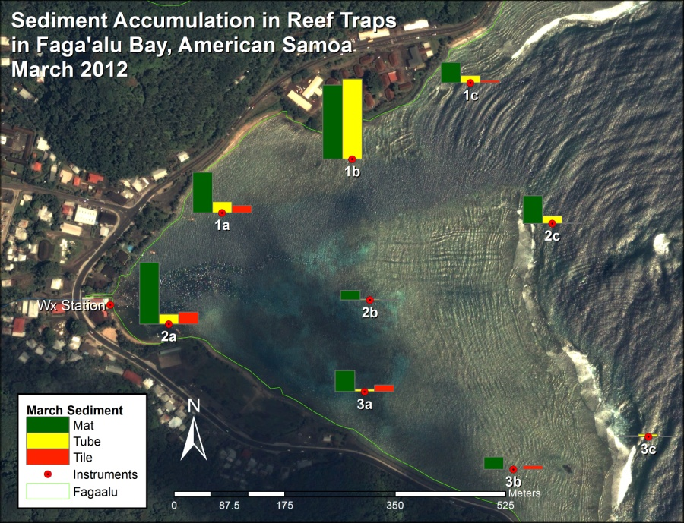

Figure . Sediment accumulation in tube, tile, and Astroturf sediment traps during pilot study, March 2012.

In February and March, 2012, total sediment accumulation was measured at nine locations on Faga’alu reef using simple tube traps (TUBE), a ceramic tile (TILE), and an Astroturf mat (MAT). From April 2013 through June 2013 sediment accumulation was measured using SedPods. Sediment accumulation included both reef-derived carbonate and terrigenous sediment, and varied according to sediment trap type, location, and ocean conditions (Figure 3). The pilot study demonstrated strong spatial variability in sediment accumulation, with high rates near the stream mouth and on the northern reef. However, the pilot study data are insufficient to test the hypotheses due to a limited number of samples (n=5), no assessment of sediment composition, and insufficient data on hydrodynamic conditions. The methods developed in the pilot study have informed the development of the methods for the proposal.

## Methods

### Measuring sediment accumulation on the reef

Deploying a TUBE in conjunction with a SedPod will allow comparison of gross and net sediment accumulation, and an assessment of the interaction of sediment loading and removal at time scales relevant to coral mortality and management. SedPods and TUBEs, deployed at nine locations on the reef flat (water depth 1-2 m) and reef crest (10-15 m) in Faga’alu Bay (Figure 3), are being collected monthly to provide data on sediment accumulation rates (mg/cm2/d) and composition from February 2014 through January 2015. Collection will be performed by Messina when in the field and by the Department of Marine and Wildlife Resources (DMWR) staff when Messina is not on-island. Sediment samples collected in tubes and SedPods will be wet sieved to the rinse salt from the sample and assess particle size (sand or fines). The samples will be dried and weighed to determine bulk sediment weight before being shipped to SDSU to characterize the geochemical composition (percent terrigenous, carbonate and organic) using Loss on Ignition (LOI) method (Heiri et al., 2001; Santisteban et al., 2004).

### Modeling sediment accumulation

Statistical models, including both simple linear regression models and more complex generalized additive mixed models (GAMMs) will be used to establish the relative controls of each measured variable on sediment accumulation rates, both the average for North and South reefs, and at each of the nine locations where accumulation is measured. Sediment accumulation at location *i* (Si) during month *t* will be calculated:

|  |  |  |
| --- | --- | --- |
|  |  | Equation 6 |
| where *Sw(t)* is total sediment loading from Faga'alu Stream in month *t*, *Ri(t)* is mean water residence time over the reef flat at location *i* (either the mean of the month or mean during storm events), and *SBi*is substrate type (live coral, dead coral, coralline sand, mud) at location *i*, which is a proxy for sediment availability in the microenvironment around the sampling location. | | |

Sediment loading from the watershed in month *t* (Sw(t)) will be calculated using the model from Paper One:

|  |  |  |
| --- | --- | --- |
|  |  | Equation 7 |
| where SW is the sum of *SSYi* for n events in the month, calculated from Equation 4. | | |

Water residence time for each 100m x 100m grid cell containing a TUBE/SedPod will be calculated from NOAA WW3 model output and the model developed in Paper Two. The relationship between swell height and residence time in each grid cell will be determined in Paper Two, of the form:

|  |  |  |
| --- | --- | --- |
|  |  | Equation 8 |
| where *Ri(t)* is the water residence time for month *t*, is mean monthly swell height, and *a* and *b* are calibration coefficients that differ for each grid cell. Depending on the modeling results from Paper Two, it may be necessary to calculate and average water residence time daily to determine mean monthly residence time, or include a term for wind-driven flow. | | |

Monthly sediment accumulation may be a function of sediment loading and hydrodynamic processes interacting on daily time scales, where hydrodynamic conditions only on the day of sediment discharge and not the mean monthly condition, are important. If monthly sediment loading and monthly mean residence time do not adequately predict sediment accumulation in the sediment traps, it might be necessary to investigate sediment loading and water residence times on daily scales, and further refine the statistical analysis and equations. In that case, daily sediment loading and daily mean residence time will be used to assess daily deposition, which can be compared to the monthly sediment accumulation measurements.

### Temporal distribution of sediment accumulation

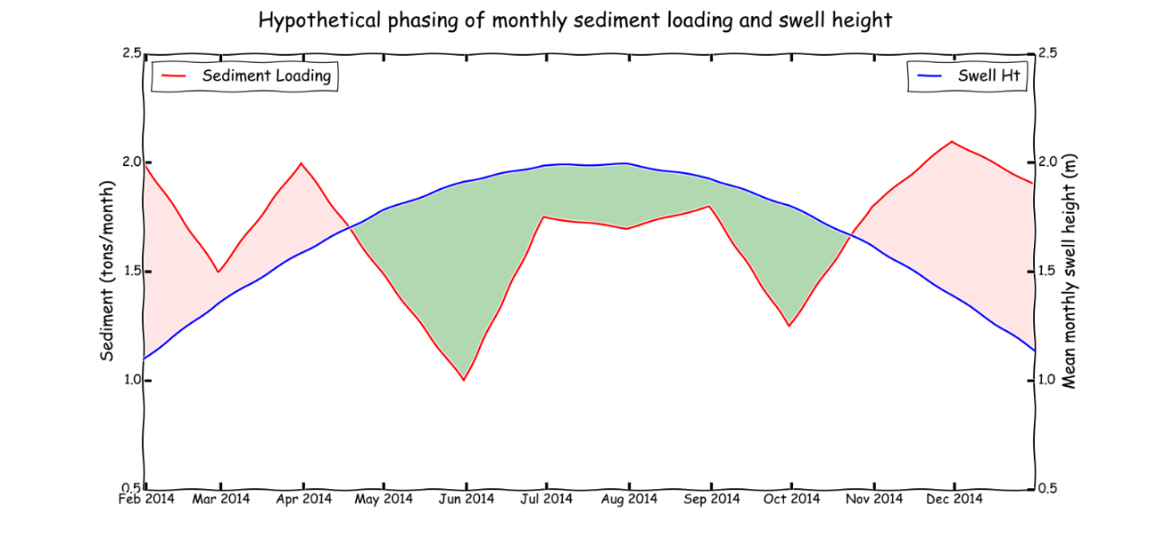

Figure . Hypothetical phasing of monthly sediment loading from the watershed and offshore wave height (Draut et al., 2009). Red shaded areas indicate a time of net terrigenous sediment accumulation and green shaded areas indicate a time of net terrigenous sediment removal and resuspension of marine-derived sediment.

Two time scales of analysis will be used: monthly and seasonal (dry and wet season). A monthly time interval was chosen to correspond with other studies found in the literature (Muzuka et al., 2010; Victor et al., 2006), to include enough storm events to collect enough sediment for analysis, and for logistical reasons due to the high spatial coverage of sites and limited field personnel and resources. Assessing differences between dry and wet season sediment dynamics is useful to determine if there are seasonal patterns or modes that may be relevant to long term sediment accumulation (Ryan et al., 2008) or coral conservation and restoration (Muzuka et al., 2010). It is hypothesized that net deposition predominantly characterizes the wet season, and a net sediment removal, or limited deposition, predominantly characterizes in the dry season (Figure 4).

### Spatial distribution of sediment accumulation

An important consideration for coral conservation is determining the spatial distribution of sediment impacts. To explain the relative spatial variation of sediment accumulation among sediment traps, and to determine if flow direction or distance from the stream is more important, all sediment accumulation measurements will be normalized by the maximum of the measured accumulation at the nine traps for a given month. Normalized values are then modeled as a function of flow velocity (towards/away the stream mouth) and distance from the stream mouth:

|  |  |  |
| --- | --- | --- |
|  |  | Equation 9 |
| where is the monthly sediment accumulation measured at trap *i in month t* SedAccMax is the highest observed sediment accumulation of all sediment traps in month t, *Vϴi* is mean flow velocity in the direction away from the stream mouth at location *i* in month *t,* and *di* is distance from the stream mouth at location *i.* | | |

## Expected Results/Outcomes

The proposed work will characterize and quantify the amount, composition, and particle sizes of sediment contributing to coral reef degradation in Faga’alu, informing mitigation strategies to reduce terrestrial sediment loading to the priority coral reef. The work will establish a baseline to measure the performance of future mitigation projects by developing a model that relates sediment loading from the watershed to sediment accumulation on the reef under varying oceanographic conditions.

# REFERENCES

Aeby, G., Aletto, S.C., Anderson, P., Carroll, B.P., DiDonato, E.M., DiDonato, G.T., Farmer, V., Fenner, D., Gove, J., Gulick, S., 2006. The State of Coral Reef Ecosystems of American Samoa.

Asselman, N.E.M., 2000. Fitting and interpretation of sediment rating curves. J. Hydrol. 234, 228–248. doi:10.1016/S0022-1694(00)00253-5

Atkinson, C., Medeiros, A., 2006. Trip Report : Pilot Study of Factors Linking Watershed Function and Coastal Ecosystem Health in American Samoa.

Bartley, R., Bainbridge, Z.T., Lewis, S.E., Kroon, F.J., Wilkinson, S.N., Brodie, J.E., Silburn, D.M., 2014. Relating sediment impacts on coral reefs to watershed sources, processes and management: a review. Sci. Total Environ. 468-469, 1138–53. doi:10.1016/j.scitotenv.2013.09.030

Bartley, R., Speirs, W.J., Ellis, T.W., Waters, D.K., 2012. A review of sediment and nutrient concentration data from Australia for use in catchment water quality models. Mar. Pollut. Bull. 65, 101–16. doi:10.1016/j.marpolbul.2011.08.009

Basher, L., Hicks, D., Clapp, B., Hewitt, T., 2011. Sediment yield response to large storm events and forest harvesting, Motueka River, New Zealand. New Zeal. J. Mar. Freshw. Res. 45, 333–356. doi:10.1080/00288330.2011.570350

Bothner, M.H., Reynolds, R.L., Casso, M.A., Storlazzi, C.D., Field, M.E., 2006. Quantity, composition, and source of sediment collected in sediment traps along the fringing coral reef off Molokai, Hawaii. Mar. Pollut. Bull. 52, 1034–47. doi:10.1016/j.marpolbul.2006.01.008

Brodie, J., Wolanski, E., Lewis, S., Bainbridge, Z., 2012. An assessment of residence times of land-sourced contaminants in the Great Barrier Reef lagoon and the implications for management and reef recovery. Mar. Pollut. Bull. 65, 267–79. doi:10.1016/j.marpolbul.2011.12.011

Burke, L., Reytar, K., Spalding, M., Perry, A., 2011. Reefs at Risk: Revisited, Defenders.

CH2M HILL, 1984. Oceanographic Studies in Support of American Samoa Wastewater Facilities Planning.

Davis, R., 1991. Lagrangian ocean studies. Annu. Rev. Fluid Mech. 23, 43–64.

Doheny, B., Maher, K., Minks, A., Rude, J., Tyner, MarleneDunne, T., 2013. Ridge to Reef: Land Use, Sedimentation, and Marine Resource Vulnerability in Raja Ampat, Indonesia. University of California, Santa Barbara.

Draut, A.E., Bothner, M.H., Field, M.E., Reynolds, R.L., Cochran, S.A.Logan, J.B., Storlazzi, C.D., Berg, C.J., 2009. Supply and dispersal of flood sediment from a steep, tropical watershed: Hanalei Bay, Kaua’i, Hawai'i, USA. Geol. Soc. Am. Bull. 121, 574–585. doi:10.1130/B26367.1

Duvert, C., Nord, G., Gratiot, N., Navratil, O., Nadal-Romero, E., Mathys, N., Némery, J., Regüés, D., García-Ruiz, J.M., Gallart, F., Esteves, M., 2012. Towards prediction of suspended sediment yield from peak discharge in small erodible mountainous catchments (0.45–22km2) of France, Mexico and Spain. J. Hydrol. 454-455, 42–55. doi:10.1016/j.jhydrol.2012.05.048

Emery, W.J., Thomson, R.E., 2004. Data Analysis Methods in Physical Oceanography, Second. ed. Elsevier B.V., Amsterdam, The Netherlands.

Fabricius, K.E., 2005. Effects of terrestrial runoff on the ecology of corals and coral reefs: review and synthesis. Mar. Pollut. Bull. 50, 125–46. doi:10.1016/j.marpolbul.2004.11.028

Fabricius, K.E., De’ath, G., Humphrey, C., Zagorskis, I., Schaffelke, B., 2012. Intra-annual variation in turbidity in response to terrestrial runoff on near-shore coral reefs of the Great Barrier Reef. Estuar. Coast. Shelf Sci. 1–9.

Falter, J.L., Atkinson, M.J., Merrifield, M. a., 2004. Mass-transfer limitation of nutrient uptake by a wave-dominated reef flat community. Limnol. Oceanogr. 49, 1820–1831. doi:10.4319/lo.2004.49.5.1820

Field, M.E., Chezar, H., Storlazzi, C.D., 2012. SedPods: a low-cost coral proxy for measuring net sedimentation. Coral Reefs. doi:10.1007/s00338-012-0953-5

Field, M.E., Cochran, S.A., Logan, J.B., Storlazzi, C.D., 2008. The coral reef of south Molokaʻi, Hawaiʻi; Portrait of a sediment-threatened reef, U.S. Geological Survey Scientific Investigations Report 2007-5101.

Garen, D.C., Moore, D.S., 2005. Curve Number Hydrology in Water Quality Modeling: Uses, Abuses and Future Directions. J. Am. Water Resour. Assoc. 41, 377–388.

Gippel, C.J., 1995. Potential of turbidity monitoring for measuring the transport of suspended solids in streams. Hydrol. Process. 9, 83–97.

Harmel, R.D., Cooper, R.J., Slade, R.M., Haney, R.L., Arnold, J.G., 2006a. Cumulative uncertainty in measured streamflow and water quality data for small watersheds. Trans. Am. Soc. Agric. Biol. Eng. 49, 689–701.

Harmel, R.D., King, K.W., Haggard, B.E., Wren, D.G., Sheridan, J.M., 2006b. Practical Guidance for Discharge and Water Quality Data Collections on Small Watersheds. Trans. ASABE 49, 937–948.

Harmel, R.D., Smith, D.R., King, K.W., Slade, R.M., 2009. Estimating storm discharge and water quality data uncertainty: A software tool for monitoring and modeling applications. Environ. Model. Softw. 24, 832–842.

Heiri, O., Lotter, A.F., Lemcke, G., 2001. Loss on ignition as a method for estimating organic and carbonate content in sediments : reproducibility and comparability of results. J. Paleolimnol. 25, 101–110.

Hench, J.L., Leichter, J.J., Monismith, S.G., 2008. Episodic circulation and exchange in a wave-driven coral reef and lagoon system. Limnol. Oceanogr. 2681–2694.

Hicks, D.M., 1990. Suspended sediment yields from pasture and exotic forest basins, in: Proceedings of the New-Zealand Hydrological Society Symposium. Auckland, New Zealand.

Hoeke, R.K., Storlazzi, C.D., Ridd, P., 2011. Hydrodynamics of a bathymetrically complex fringing coral reef embayment: Wave climate, in situ observations, and wave prediction. J. Geophys. Res. 116, C04018.

Hoitink, A.J.F., Hoekstra, P., 2003. Hydrodynamic control of the supply of reworked terrigenous sediment to coral reefs in the Bay of Banten (NW Java, Indonesia). Estuar. Coast. Shelf Sci. 58, 743–755.

Jacob, L., Wiles, P., Aitaoto, T., Yuen, S.L., 2012. Coastal Currents in American Samoa. Their Role in Marine Protected Area Network Design.

Johnson, D., Stocker, R., Head, R., Imberger, J., Pattiaratchi, C., 2003. A Compact , Low-Cost GPS Drifter for Use in the Oceanic Nearshore Zone , Lakes , and Estuaries. J. Atmos. Ocean. Technol. 20, 1880–1884.

Klein, C.J., Jupiter, S.D., Selig, E.R., Watts, M.E., Halpern, B.S., Kamal, M., Roelfsema, C., Possingham, H.P., 2012. Forest conservation delivers highly variable coral reef conservation outcomes. Ecol. Appl. 22, 1246–56.

Lewis, J., 1996. Turbidity-controlled suspended sediment sampling for runoff-event load estimation. Water Resour. Res. 32, 2299–2310.

Lewis, J., Mori, S.R., Keppeler, E.T., Ziemer, R.R., 2001. Impacts of Logging on Storm Peak Flows , Flow Volumes and Suspended Sediment Loads in Caspar Creek, CA, in: Land Use and Watersheds: Human Influence on Hydrology and Geomorphology in Urban and Forest Areas. pp. 1–76.

Lowe, R.J., Falter, J.L., Monismith, S.G., Atkinson, M.J., 2009. Wave-Driven Circulation of a Coastal Reef–Lagoon System. J. Phys. Oceanogr. 39, 873–893. doi:10.1175/2008JPO3958.1

MacMahan, J., Brown, J., Brown, J., Thornton, E., Reniers, A., Stanton, T., Henriquez, M., Gallagher, E., Morrison, J., Austin, M.J., Scott, T.M., Senechal, N., 2010. Mean Lagrangian flow behavior on an open coast rip-channeled beach: A new perspective. Mar. Geol. 268, 1–15. doi:10.1016/j.margeo.2009.09.011

MacMahan, J., Brown, J., Thornton, E., 2009. Low-Cost Handheld Global Positioning System for Measuring Surf-Zone Currents Low-Cost Handheld Currents Positioning System for Measuring. J. Coast. Res. 25, 744–754.

Milliman, J.D., Syvitski, J.P.M., 1992. Geomorphic/tectonic control of sediment discharge to the ocean: the importance of small mountainous rivers. J. Geol. 525–544.

Muzuka, A.N.N., Dubi, A.M., Muhando, C.A., Shaghude, Y.W., 2010. Impact of hydrographic parameters and seasonal variation in sediment fluxes on coral status at Chumbe and Bawe reefs, Zanzibar, Tanzania. Estuar. Coast. Shelf Sci. 89, 137–144.

Ouillon, S., Douillet, P., Lefebvre, J.P., Le Gendre, R., Jouon, a, Bonneton, P., Fernandez, J.M., Chevillon, C., Magand, O., Lefèvre, J., Le Hir, P., Laganier, R., Dumas, F., Marchesiello, P., Bel Madani, a, Andréfouët, S., Panché, J.Y., Fichez, R., 2010. Circulation and suspended sediment transport in a coral reef lagoon: the south-west lagoon of New Caledonia. Mar. Pollut. Bull. 61, 269–96. doi:10.1016/j.marpolbul.2010.06.023

Perry, C., Smithers, S.G., Gulliver, P., Browne, N.K., 2012. Evidence of very rapid reef accretion and reef growth under high turbidity and terrigenous sedimentation. Geology 40, 719–722. doi:10.1130/g33261.1

Presto, M.K., Ogston, A.S., Storlazzi, C.D., Field, M.E., 2006. Temporal and spatial variability in the flow and dispersal of suspended-sediment on a fringing reef flat, Molokai, Hawaii. Estuar. Coast. Shelf Sci. 67, 67–81. doi:10.1016/j.ecss.2005.10.015

Rankl, J.G., 2004. Relations Between Total-Sediment Load and Peak Discharge for Rainstorm Runoff on Five Ephemeral Streams in Wyoming.

Reid, L.M., Dunne, T., 1996. Rapid evaluation of sediment budgets. Catena Verlag.

Risk, M.J., 2014. Assessing the effects of sediments and nutrients on coral reefs. Curr. Opin. Environ. Sustain. 7, 108–117. doi:10.1016/j.cosust.2014.01.003

Ryan, K.E., Walsh, J.P., Corbett, D.R., Winter, a, 2008. A record of recent change in terrestrial sedimentation in a coral-reef environment, La Parguera, Puerto Rico: a response to coastal development? Mar. Pollut. Bull. 56, 1177–83. doi:10.1016/j.marpolbul.2008.02.017

Santisteban, J.I., Mediavilla, R., Lopez-Pamo, E., Dabrio, C.J., Zapata, M.B.R., Garcia, M.J.G., Castano, S., Martínez-Alfaro, P.E., 2004. Loss on ignition: a qualitative or quantitative method for organic matter and carbonate mineral content in sediments? J. Paleolimnol. 32, 287–299.

Slaymaker, O., 2003. The sediment budget as conceptual framework and management tool. Hydrobiologia 494, 71–82.

Stock, J.D., Rosener, M., Schmidt, K.M., Hanshaw, M.N., Brooks, B.A., Tribble, G., Jacobi, J., 2010. Sediment budget for a polluted Hawaiian reef using hillslope monitoring and process mapping, in: American Geophysical Union Fall Meeting. p. abstract#EP22A–01.

Storlazzi, C.D., Brown, E.K., Field, M.E., 2006a. The application of acoustic Doppler current profilers to measure the timing and patterns of coral larval dispersal. Coral Reefs 25, 369–381. doi:10.1007/s00338-006-0121-x

Storlazzi, C.D., Field, M.E., Bothner, M.H., 2011. The use (and misuse) of sediment traps in coral reef environments: theory, observations, and suggested protocols. Coral Reefs 30, 23–38.

Storlazzi, C.D., Field, M.E., Bothner, M.H., Presto, M.K., Draut, A.E., 2009. Sedimentation processes in a coral reef embayment: Hanalei Bay, Kauai. Mar. Geol. 264, 140–151. doi:10.1016/j.margeo.2009.05.002

Storlazzi, C.D., Jaffe, B.E., 2008. The relative contribution of processes driving variability in flow, shear, and turbidity over a fringing coral reef: West Maui, Hawaii. Estuar. Coast. Shelf Sci. 77, 549–564.

Storlazzi, C.D., McManus, M. a., Logan, J.B., McLaughlin, B.E., 2006b. Cross-shore velocity shear, eddies and heterogeneity in water column properties over fringing coral reefs: West Maui, Hawaii. Cont. Shelf Res. 26, 401–421. doi:10.1016/j.csr.2005.12.006

Storlazzi, C.D., Ogston, A.., Bothner, M.., Field, M.., Presto, M.., 2004. Wave- and tidally-driven flow and sediment flux across a fringing coral reef: Southern Molokai, Hawaii. Cont. Shelf Res. 24, 1397–1419. doi:10.1016/j.csr.2004.02.010

Storlazzi, C.D., Presto, M.K., Logan, J.B., Field, M.E., 2006c. Coastal circulation and sediment dynamics in Hanalei Bay, Kauai. Part I, Measurements of waves, currents, temperature, salinity and turbidity: June-August, 2005, U.S. Geological Survey open-file report 2006-1085. U.S. Geological Survey, Santa Cruz, California.

Syvitski, J.P.M., Vörösmarty, C.J., Kettner, A.J., Green, P., 2005. Impact of humans on the flux of terrestrial sediment to the global coastal ocean. Science (80-. ). 308, 376–380.

Thompson, E.F., Demirbilek, Z., 2002. Wave Response , Pago Pago Harbor , Island of Tutuila , Territory of American Samoa Coastal and Hydraulics Laboratory.

Topping, J., 1972. Errors of Observation and their Treatment, 4th ed. Chapman and Hall, London, UK.

Vetter, O., 2013. Fagaalu Oceanographic Document.

Vetter, O., Becker, J.M., Merrifield, M.A., Pequignet, A.C., Aucan, J., Boc, S.J., Pollock, C.E., 2010. Wave setup over a Pacific Island fringing reef. J. Geophys. Res. 115, C12066.

Victor, S., Neth, L., Golbuu, Y., Wolanski, E., Richmond, R.H., 2006. Sedimentation in mangroves and coral reefs in a wet tropical island, Pohnpei, Micronesia. Estuar. Coast. Shelf Sci. 66, 409–416. doi:10.1016/j.ecss.2005.07.025

Warrick, J. a., Mertes, L. a. K., 2009. Sediment yield from the tectonically active semiarid Western Transverse Ranges of California. Geol. Soc. Am. Bull. 121, 1054–1070. doi:10.1130/B26452.1

Warrick, J.A., Mertes, L.A.K., Washburn, L., Siegel, D.A., 2004. Dispersal forcing of southern California river plumes, based on field and remote sensing observations. Geo-Marine Lett. 24, 46–52.

West, K., van Woesik, R., 2001. Spatial and temporal variance of river discharge on Okinawa (Japan): inferring the temporal impact on adjacent coral reefs. Mar. Pollut. Bull. 42, 864–72.

White, J., 1990. The use of sediment traps in high-energy environments. Mar. Geophys. Res. 12, 145–152.

White, M.D., Greer, K. a., 2006. The effects of watershed urbanization on the stream hydrology and riparian vegetation of Los Peñasquitos Creek, California. Landsc. Urban Plan. 74, 125–138. doi:10.1016/j.landurbplan.2004.11.015

Wiles, P., Aitaoto, T., Lam Yuen, S., 2012. Coastal Currents in American Samoa. Their Role in Marine Protected Area Network Design. Department of Marine and Wildlife Resources, American Samoa.

Wolanski, E., Richmond, R.H., Davis, G., Bonito, V., 2003. Water and fine sediment dynamics in transient river plumes in a small, reef-fringed bay, Guam. Estuar. Coast. Shelf Sci. 56, 1029–1040. doi:10.1016/S0272-7714(02)00321-9

Wyatt, A.S.J., Falter, J.L., Lowe, R.J., Humphries, S., Waite, A.M., 2012. Oceanographic forcing of nutrient uptake and release over a fringing coral reef. Limnol. Oceanogr. 57, 401–419. doi:10.4319/lo.2012.57.2.0401

Wyatt, A.S.J., Lowe, R.J., Humphries, S., Waite, A., 2010. Particulate nutrient fluxes over a fringing coral reef: relevant scales of phytoplankton production and mechanisms of supply. Mar. Ecol. Prog. Ser. 405, 113–130. doi:10.3354/meps08508